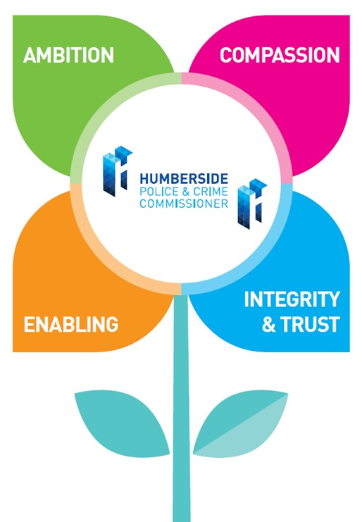**Your Job Title:** Assurance Administrator (Compliance)

**Your Salary and Rewards:** This is a Band F role

**Your Contribution to the OPCC will be:**

Provide administrative support to the Assurance and Statutory Operations Team, supporting our compliance function.

**Your business as usual will include:**

* Supporting with building-related matters and acting as a Single Point of Contact for all maintenance and repairs.
* Providing support for the business’s health and safety requirements
* Raising staff awareness and advising on compliance matters
* Maintaining fire safety equipment and first aid kits
* Provide meeting and administrative support for the Assurance and Statutory Operations Team as required.
* General compliance administrative duties, including:
* Organising staff compliance training schedule and regular and ad-hoc training
* Assisting with data protection requirements
* Maintaining a register of policies and procedures, triggering reviews where appropriate
* Maintaining and developing forms and templates
* Perform such other duties as reasonably correspond to the general character of the post and are commensurate with its level of responsibility.

|  |  |  |
| --- | --- | --- |
| **Decision Making** | **Leadership** | **Managing Risk** |
| Has limited decision making requirements.  Would usually follow specific process as directed by line manager. | Will engage with a range of partners usually in a light touch manner e.g. diary management, correspondence with individuals rather than maintaining ongoing working relationships. | Will identify risks and make suggestions around how to mitigate and manage them. |

**How you fit:**

You will be managed by our Compliance Manager, who will provide you with both challenge and support in your role with us. You may also receive daily supervision from senior colleagues who will challenge and support you in your role with us. (Please see the diagram below of our structure.)

**Our Values:**

We thought really carefully about our values, and they are owned by everyone.

They are used as the foundation for all we do and a fundamental part of how we undertake recruitment and selection.

There is an expectation that collectively we will strive to achieve great things, enjoy our work, make one another proud, and work with the public in mind at all times.

|  |  |
| --- | --- |
| **AMBITION** | You are persistent and determined – using setbacks as a way to grow and improve further.  You never place ambition above maintaining high ethical standards and acting with integrity.  You want the best levels of service for the communities we serve. |
| **COMPASSION** | You don’t hesitate to go the extra mile for others.  You stop and consider what is going on for other people, and amend your approach accordingly.  You want service delivery that places people first. |
| **ENABLING** | You connect, collaborate, cooperate, consider, and contribute.  You see possibilities to bring people and resources together to make things happen.  You use the assets of the OPCC to create opportunities that benefit the public. |
| **INTEGRITY & TRUST** | You are authentic and build real rapport with others you work with and for.  You understand that your actions represent the OPCC at all times.  You work to the ethos of the Nolan principles of public life. |

**You will have:**

* Have experience of a range of office procedures with excellent word processing and organisation skills.
* Be competent, with skills to compile and maintain computerised and manual records.
* Have strong interpersonal and communication skills, enabling effective liaison with people in person, in writing and over the telephone.
* Be literate and numerate, with excellent verbal and written communication skills and have a good level of education and a GCSE in English or equivalent.
* Demonstrate a commitment to Continuous Professional Development (CPD).
* Have experience of working in an office environment.
* Have excellent attention to detail and a flexible and responsive approach.
* Be able to collate and provide information accurately with pre-determined time scales, effectively interpreting guidance notes.
* A positive ‘can do’ attitude and a passion for our communities across the Humber region.
* Flexibly meet the demands of the post, with a willingness to learn and undertake a variety of tasks.
* Be able to organise your own workload.

**You may have:**

* Have experience of working within a governance or statutory role.
* Have experience of working with sensitive and confidential information.
* Have experience of working within statutory and compliance frameworks.
* Have knowledge of Health and Safety and other compliance approaches.
* Be confident in accessing and using a range of social media platforms.
* Track record/experience and/or degree or qualification that demonstrates an ability to operate at a level to support strategic leaders of the OPCC.

**Our Organisation – Our People**

